|  |  |
| --- | --- |
| **Ex. No. 10** | **ANGULAR JS FORMS** |
| Date of Exercise | 02/11/2022 |
| GitHub Link |  |
| Video Link | https://drive.google.com/file/d/1Uc_iYuZz-L56uIcK2fEdT5gozb3XDwYZ/view?usp=share_link |

**Aim**

(a)Create Christmas Megaplay 2022 registration form and perform validation using angular JS.  
(b)Create a webpage to perform show multiple regno and display the profile of the on clicking the regno selected using Routing concept in Angular Js.

**Description**

* Input controls provides data-binding by using the ng-model directive.
* The ng-model directive binds the input controller to the rest of your application.
* The property firstname, can be referred to in a controller
* The property secondname, can be referred to in a controller
* And repeat the same thing for email and password
* Use ‘required’ to check whether all the text are filled in the text area.
* Use checkboxes to let the users give feedbacks about their experience
* Apply the ng-model directive to a checkbox, and use its value in your application.
* Bind radio buttons to your application with the ng-model directive.
* Use radio buttons to let the users to give ratings .
* Radio buttons with the same ng-model can have different values, but only the selected one will be used.

**HTML CODE**

**Q1:**

<!DOCTYPE html>

<html lang="en">

<head>

    <title>User Registration Form</title>

    <script src="https://ajax.googleapis.com/ajax/libs/angularjs/1.6.9/angular.min.js"></script>

    <script>

        var app = angular.module('myapp', []);

        app.controller('mycontrol', function($scope){

            $scope.namepattern = /[a-zA-Z]/;

            $scope.departmentpattern = /[a-zA-Z]/;

            $scope.passpattern = /^[a-zA-Z0-9]{10}$/;

            $scope.mobpattern = /[0-9]{10}/;

            $scope.agepattern = /[0-9]{2}/;

            $scope.yearpattern = /[1-4]{1}/;

        });

    </script>

</head>

<body ng-app="myapp" ng-controller="mycontrol">

    <h1 style="color: blue;margin: 30px;">User Registration Form</h1>

    <form name="myform" style="margin: 5px 30px;">

        Name<span style="color: red;">*</span> &emsp;&emsp;&emsp;&emsp;&emsp;

        <input type="text" name="myname" ng-model="name" ng-pattern="namepattern" required>

        <span style="color: red;" ng-show="myform.myname.$dirty && myform.myname.$error.required">Name is required...</span>

        <span style="color: red;" ng-show="myform.myname.$dirty && myform.myname.$error.pattern">Name Format is wrong...</span><br><br>

        Department<span style="color: red;">*</span> &emsp;&emsp;&emsp;

        <input type="text" name="mydepartment" ng-model="department" ng-pattern="departmentpattern" required>

        <span style="color: red;" ng-show="myform.mydepartment.$dirty && myform.mydepartment.$error.required">Department is required...</span>

        <span style="color: red;" ng-show="myform.mydepartment.$dirty && myform.mydepartment.$error.pattern">Department Format is wrong...</span><br><br>

        Age<span style="color: red;">*</span> &emsp;&emsp;&emsp;&emsp;&emsp;&emsp;

        <input type="number" name="myage" ng-model="age" ng-pattern="agepattern" required>

        <span style="color: red;" ng-show="myform.myage.$dirty && myform.myage.$error.required">Age is required...</span>

        <span style="color: red;" ng-show="myform.myage.$dirty && myform.myage.$error.pattern">Not eligible...</span><br><br>

        Year<span style="color: red;">*</span> &emsp;&emsp;&emsp;&emsp;&emsp;&emsp;

        <input type="number" name="myyear" ng-model="year" ng-pattern="yearpattern" required>

        <span style="color: red;" ng-show="myform.myyear.$dirty && myform.myyear.$error.required">Year is required...</span>

        <span style="color: red;" ng-show="myform.myyear.$dirty && myform.myyear.$error.pattern">Between 1 and 4...</span><br><br>

        Mobile Number <span style="color: red;">*</span> &emsp;

        <input type="number" name="mymobilenum" ng-model="mobilenum" ng-pattern="mobpattern" required>

        <span style="color: red;" ng-show="myform.mymobilenum.$dirty && myform.mymobilenum.$error.required">Mobile Number is required...</span>

        <span style="color: red;" ng-show="myform.mymobilenum.$dirty && myform.mymobilenum.$error.pattern">Format is wrong...</span><br><br>

        Email<span style="color: red;">*</span>&emsp;&emsp;&emsp;&emsp;&emsp;&ensp;

        <input type="email" name="mymail" ng-model="mail" required>

        <span style="color: red;" ng-show="myform.mymail.$dirty && myform.mymail.$error.required">Email is required...</span>

        <span style="color: red;" ng-show="myform.mymail.$dirty && myform.mymail.$error.email">Email Format is wrong...</span><br><br>

        Gender<span style="color: red;">*</span> &emsp;&emsp;&emsp;&emsp;&ensp;

        <input type="radio" name="mygender" ng-model="male" required>Male

        <input type="radio" name="mygender" ng-model="female" required>Female<br><br>

        Talent<span style="color: red;">*</span> &emsp;&emsp;&emsp;&emsp;&emsp;&emsp;

        <select name="mytalent" id="talent">

            <option value="Acting">Acting</option>

            <option value="Singing">Singing</option>

            <option value="Dancing">Dancing</option>

            <option value="MC">MC</option>

        </select><br><br>

        <button type="submit">Submit</button>

    </form>

</body>

</html>

**Q2:**

**About1.html**

<h1>About Us</h1>

<br>

<p>

    <b>Profiles of Four Students:</b>

    <br>

    &emsp; 1.URK20CS2087

    <br>

    &emsp; 2.URK20CS2082

    <br>

    &emsp; 3.URK20CS2099

    <br>

    &emsp; 4.URK20CS1020

</p>

**2087.html**

<h1>Sumeet Kumar Gamango</h1>

<br><br>

<p>

    <b>Register Number:</b>URK20CS2087

    <br>

    <b>Course: </b>B.Tech Computer Science and Engineering(Specialization in Artificial Intelligence)

    <br>

    <b>Current Year: </b>3

    <br>

    <b>Year of Duration:</b>2020-2024

    <br>

    <b>Address:</b>Bhubaneswar,Odisha

    <br>

    <b>10th Degree:</b>Podar International School (CBSE Board)-2018

    <br>

    <b>12th Degree:</b>Gouri Shankar Residentail School (CBSE Board)-2020

</p>

**2082.html**

<h1>Anmol Ephraim</h1>

<br><br>

<p>

    <b>Register Number:</b>URK20CS2082

    <br>

    <b>Course: </b>B.Tech Computer Science and Engineering(Specialization in Artificial Intelligence)

    <br>

    <b>Current Year: </b>3

    <br>

    <b>Year of Duration:</b>2020-2024

    <br>

    <b>Address:</b>Bilaspur,Chattisgarh

    <br>

    <b>10th Degree:</b>St.Xavier High School (CBSE Board)-2018

    <br>

    <b>12th Degree:</b>St.Xavier High School (CBSE Board)-2020

</p>

**2099.html**

<h1>Glimpson Gidhi</h1>

<br><br>

<p>

    <b>Register Number:</b>URK20CS2099

    <br>

    <b>Course: </b>B.Tech Computer Science and Engineering(Specialization in Artificial Intelligence)

    <br>

    <b>Current Year: </b>3

    <br>

    <b>Year of Duration:</b>2020-2024

    <br>

    <b>Address:</b>Ranchi,Jharkhand

    <br>

    <b>10th Degree:</b>Mother's Public School (CBSE Board)-2018

    <br>

    <b>12th Degree:</b>Podar International School (CBSE Board)-2020

</p>

**1020.html**

<h1>Akash Rathod</h1>

<br><br>

<p>

    <b>Register Number:</b>URK20CS1020

    <br>

    <b>Course: </b>B.Tech Computer Science and Engineering

    <br>

    <b>Current Year: </b>3

    <br>

    <b>Year of Duration:</b>2020-2024

    <br>

    <b>Address:</b>Mumbai,Maharashtra

    <br>

    <b>10th Degree:</b>Kendriya Vidyalaya School (CBSE Board)-2018

    <br>

    <b>12th Degree:</b>Kendriya Vidyalaya School (CBSE Board)-2020

</p>

**index.html**

<!DOCTYPE html>

<html lang="en">

<head>

    <meta charset="UTF-8">

    <meta http-equiv="X-UA-Compatible" content="IE=edge">

    <meta name="viewport" content="width=device-width, initial-scale=1.0">

    <link rel="stylesheet" href="style.css">

    <script src="https://ajax.googleapis.com/ajax/libs/angularjs/1.6.9/angular.min.js"></script>

    <script src="https://ajax.googleapis.com/ajax/libs/angularjs/1.6.9/angular-route.js"></script>

    <script>

        var app = angular.module('myapp', ['ngRoute']);

        app.config(function($routeProvider){

            $routeProvider.when('/about1', {

                templateUrl: 'about1.html'

            })

            .when('/2087', {

                templateUrl: '2087.html'

            })

            .when('/2082', {

                templateUrl: '2082.html'

            })

            .when('/2099', {

                templateUrl: '2099.html'

            })

            .when('/1020', {

                templateUrl: '1020.html'

            })

        });

    </script>

</head>

<body ng-app="myapp">

    <h1>Profiles</h1>

    <hr>

    <div class="sidebar">

        <a href="#!about1">About</a>

        <a href="#!2087">URK20CS2087</a>

        <a href="#!2082">URK20CS2082</a>

        <a href="#!2099">URK20CS2099</a>

        <a href="#!1020">URK20CS1020</a>

    </div>

    <div class="content" ng-view>

    </div>

</body>

</html>

**css file**

*{

    margin: 0;

}

html, body{

    height: 100%;

}

h1{

    text-align: center;

    padding: 16px;

    color: rgb(239, 210, 210);

    background-color: #000000;

}

.sidebar{

    width: 19%;

    height: 100%;

    float: left;

    border-right: 1px solid rgb(155, 153, 153);

    text-align: center;

}

a{

    font-size: 20px;

    width: 120px;

    text-align: center;

    border-radius: 8px;

    margin: 32px 70px;

    text-decoration: none;

    color: gold;

    background-color: #000000;

    padding: 8px;

    display: block;

}

.content{

    width: 77.5%;

    height: 100%;

    float: left;

    border: 1px solid gold;

    padding: 18px;

    color: gold

}

p{

    font-size: 24px;

    line-height: 0 32px;

    text-align: justify;

    width: 96%;

    margin-top: 16px;

    color: gold

}

**OUTPUT**

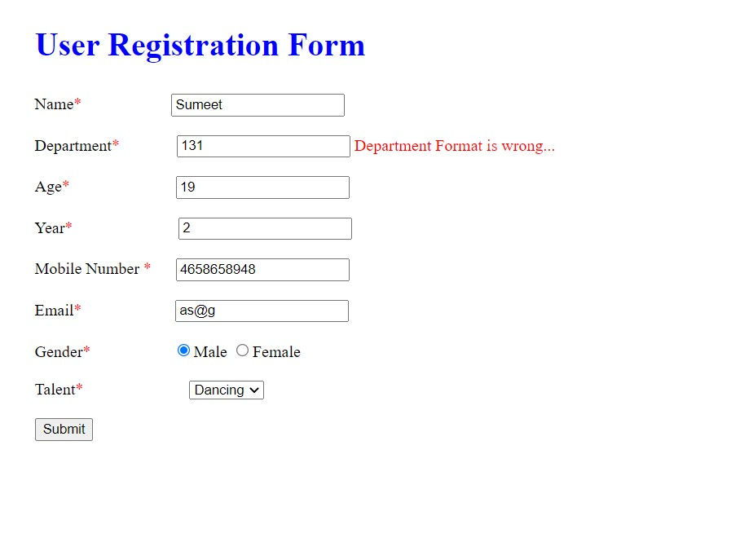

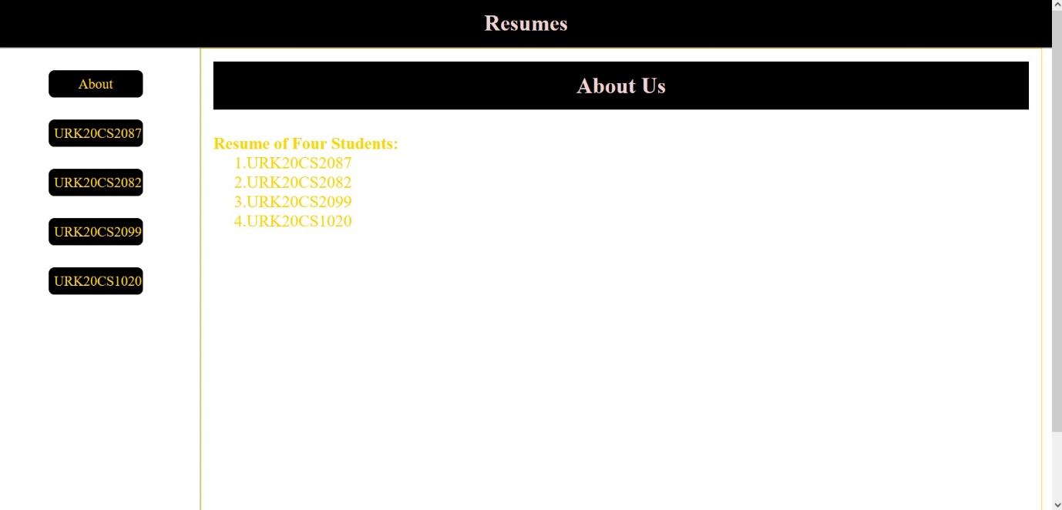

**RESULT**

The program was done successfully and the data from the file has been printed in another browser using node js.